|  |
| --- |
| Functional Design Document |
| CHG215394: |
| Account Updates Work flow |
| Markets: UK |
| Release: RLS000700 (Feb’22) |



Contents

A. Document approval 3

B. Revision history 3

1. Business Process Overview 4

1.1 Process Overview 4

1.2 Impact Matrix 4

2. Description of the functional change 5

2.1 Changes in Siebel Sales 5

2.2 English Captions 5

2.3 Changes in the ETL 5

2.3.1 Initial Loads/Massive Data updates 6

2.3.2 Performance test/Indexes creation 6

2.4 Changes in OBI 6

2.5 Data Dictionary 7

2.6 Changes in Data Interfaces 7

2.6.1 Inbound 7

2.6.2 Outbound 8

2.6.3. Initial Loads 8

2.6.4 Performance test / Indexes creation 8

2.7 Changes in Batch Processes / Aggregations / DRP 8

2.8 Use Case 8

# Document approval

*List members from market, DBU, BTS, ODC, GTC and other teams that are accountable and responsible for the CHG implementation. Add extra rows if required to include extra team members (e.g. responsible for different areas or services).*

|  |  |  |
| --- | --- | --- |
| Role | Name | Function |
| **Market Sponsor** | Phil Guilfoyle | TME Manager UK |
| **DBU Approver** | Nikita Ryzhkovich | Digital Customer Experience |
| **BTS expert** | Sonia Fernandez | BTS TME Manager |
| **ODC expert** | David Gallego | ODC Sales |
| **ODC expert** | Miguel Lopez | ODC Data |
| **GTC expert** | Jose Carlos Martin | TME Tech Arch Mgr |

This is to confirm that we have reviewed the functional specifications for the proposed solution. We agree with its contents and understand that the technical specifications will be designed based on this approved document.

# Revision history

|  |  |  |  |  |
| --- | --- | --- | --- | --- |
| Revision | Section(s) | Description | Editor | Date |
| 1.0 | - | Draft | S. Fernandez | 07.09.2021 |
| 1,1 |  | Modifications after discussion with ODC | S. Fernandez | 29.09.2021 |
|  |  |  |  |  |
|  |  |  |  |  |
|  |  |  |  |  |
|  |  |  |  |  |
|  |  |  |  |  |
|  |  |  |  |  |

# Business Process Overview

## Process Overview

*Provide brief and meaningful information about the requested change, explain current situation, and estimated future improvements. Use Description, Benefits and Impact provide by market in the CHG.*

Currently, field based employees inform the Admin Team when updates are required for Account records via email (circa 600-700 updates each cycle), this involves a great deal of repetition – from the TM typing out the request to the Admin team copying and pasting to within the Application – one record at a time.

To streamline this process the Market, require a form\update request for the top 5 update requests which would be checked and approved either on as a mass update or record by record.

With this we will achieve time saving for end users, that will not waste time by updating accounts one by one. By centralizing the TME update requests, none are lost in error and by "automating" updates Team Members are able to focus on completing Agile tasks within the Commercial Planning Team.

## Impact Matrix

|  |  |
| --- | --- |
| GRM Functionality | Accounts |
| Impact Current Functionality? | Yes |
| Markets Affected | UK |
| Applications Affected | Sales/Data/OBIEE |
| Risk of Implementing the change | Low |

# Description of the functional change

## Changes in Siebel Sales

1. New fields

In the Visit – Rep Amendments view (GAL ME Rep Amendments View), market would need the following fields to be added:

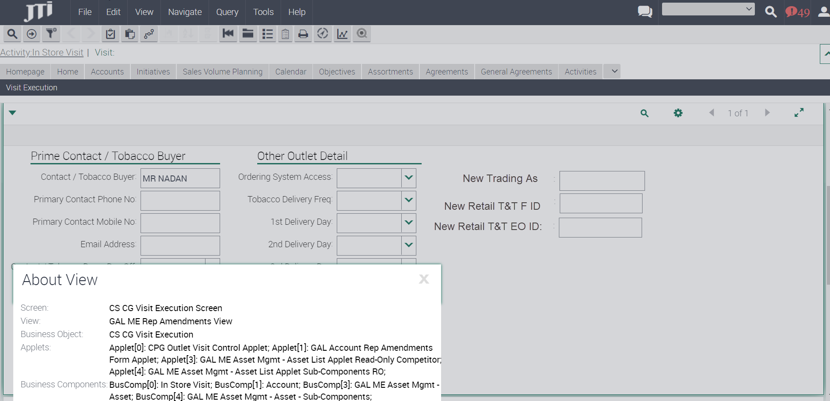

Please note that these are not the existing fields for an Account, these would be new fields that the TMs will use to introduce the proposed values for the update of the original fields.

Fields to include:

* + New Trading As: Free Type. This field should be stored in upper case always.
  + New Retail T&T EO_ID
  + New Retail T&T F_ID

The fields should have the same type, format, and validations of the original fields. For the T&T fields the following additional validations should apply:

* Contains 13 characters. Validation message to be shown: “This field must contain 13 characters. Contact a member of the TME Support Team for assistance”.
* Alphanumeric Characters only (no symbols i.e $&!@* etc). Validation message to be shown: “This field can only contain alphanumeric characters. Contact a member of the TME Support Team for assistance”.
* F_ID begins with QCGDLRF. This string to do the validation should be configurable in case it changes with time. “This F_ID needs to begin with QCGDLRE. Contact a member of the TME Support Team for assistance”.
* EO_ID begins with QCGDLRE. This string to do the validation should be configurable in case it changes with time. Validation message to be shown: “This EO_ID needs to begin with QCGDLRE. Contact a member of the TME Support Team for assistance”.
* New Retail T&T F_ID cannot be duplicated in TME. No other UK Account, no matter the status of the Account, can have this same field value. Validation message to be shown: “This F_ID is already registered to another Account within TME. Contact a member of the TME Support Team for assistance”.

A new field Update Status would be needed in Account with possible values Pending, Approved, Rejected.

When one of these 3 fields: New Trading As, New T&T EO_ID or New T&T F_ID are informed, we need to save the information of the user who updated the field (the login of the user would be enough) and the date in which the fields were updated in two new fields: Details of Requester, Date Requested. We should also modify Update Status field to Pending value.

If all the three New fields are emptied by the TM, the Update Status, Details of Requester, Date Requested fields should also be nullified.

1. Approval process

New view called – All Account update pending approvals

This view should be located inside Account Administration Screen and should only be available for Local Administrators.

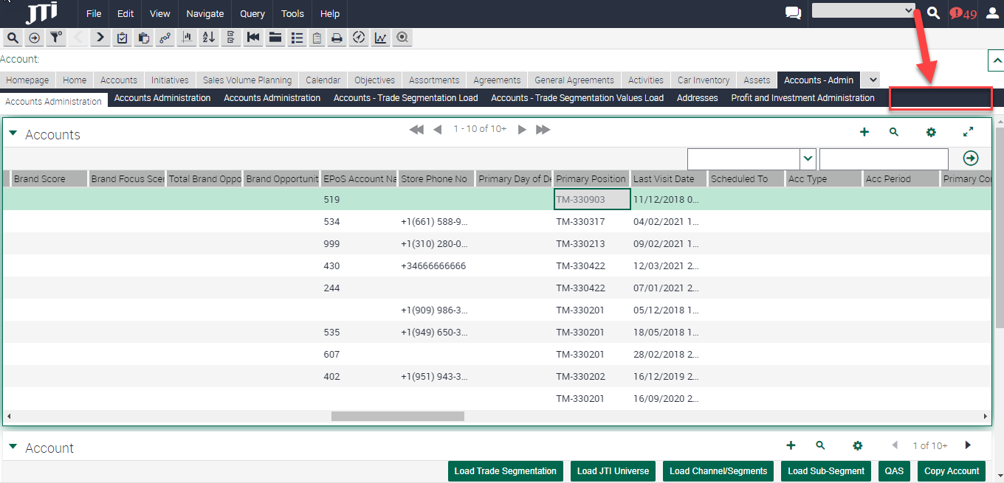

In this view only the Accounts with any of the fields: New Trading As, New T&T EO_ID or New T&T F_ID informed should be shown. The filter could be done with new field Update Status=Pending. The following fields should be available on this view in Read Only mode:

* + Trading As
  + T&T EO_ID
  + T&T F_ID
  + New Trading As
  + New Retail T&T EO_ID
  + New Retail T&T F_ID
  + Update Status
  + Account Code
  + Postcode – of the primary address of the Account
  + Primary Position – Account Administration field list applet
  + Account Handler position – Account Administration field
  + Date Requested
  + Details of Requester

The view needs to have two buttons: Approve and Reject. If the user presses the Approve button, the information present on fields New Trading As, New Retail T&T EO_ID and New Retail T&T F_ID should be copied into fields Trading As, T&T EO_ID and T&T F_ID and the new fields should be emptied. Market should be able to **approve several records at the same time massively**. Upon approval Update Status field should be modified to Approved.

When the user approves the change, we need to inform two new fields: Details of Approver/Rejection (the login of the user who approved) and Date Approved/Rejected.

If Reject button is pressed, fields New Trading As, New Retail T&T EO_ID and New Retail T&T F_ID are deleted without copying them into the original fields. User can only **reject records one by one**.

When the user rejects the change, we need to inform two new fields: Details of Approver/Rejection (the login of the user who rejected) and Date Approved/Rejected. Update Status should also be modified to Rejected.

The approval/Rejection buttons would approve or reject all changes for an Account.

1. Historical view

Market would need a new view called ‘All Account update approvals history’, that should also be located inside Accounts Administration Screen.

In this view the history of all the changes approved in the approval view should be shown, including the fields:

* + Trading As
  + T&T EO_ID
  + T&T F_ID
  + New Trading As
  + New Retail T&T EO_ID
  + New Retail T&T F_ID
  + Update Status
  + Account Code
  + Postcode
  + Primary Position
  + Account Handler position
  + Date Requested
  + Date Approved/Rejected
  + Details of Requester
  + Details of Approver/Rejection

**Note to ODC: The decision of implementing this view in Sales or only in OBIEE is left to technical team, but we need to ensure that all the information needed including both original field values and new field values is going to be visible in the historical view, alongside the details of the approval/rejection of the update (Update Status, Date Approved/Rejected, Details of Approved/Rejection fields). We must also ensure that the fields: New Trading As, New Retail T&T EO_ID, New Retail T&T F_ID, Update Status, Date Requested, Date Approved/Rejected, Details of Requested and Details of Approved/Rejection would be deleted from Sales and OBIEE once the update has been approved or rejected, so that both TMs and Backoffice can know that these Account updates have already been approved/rejected. Once the record has been approved/rejected, these fields should remain informed only in the historical view.**

## English Captions

|  |  |  |  |  |
| --- | --- | --- | --- | --- |
| Type | Format | Caption ENU | Language | Caption LOCAL |
| *Field/Button/View* |  | *Visit* | *ESP* | *Visita* |
|  |  |  |  |  |

## Changes in the ETL

|  |  |  |  |  |  |
| --- | --- | --- | --- | --- | --- |
|  | OLTP Source | | ETL | OLAP Target | |
| # | **Entity** | **Attribute** | **Transformation** | **Entity** | **Attribute** |
| 1 | Account | New Trading As |  | Account | New Trading As |
| 2 | Account | New Retail T&T EO_ID |  | Account | New Retail T&T EO_ID |
| 3 | Account | New Retail T&T F_ID |  | Account | New Retail T&T F_ID |
| 4 | Account | Update Status |  | Account | Update Status |
| 5 | Account | Date Requested |  | Account | Date Requested |
| 6 | Account | Date Approved/Rejected |  | Account | Date Approved/Rejected |
| 7 | Account | Details of Requester |  | Account | Details of Requester |
| 8 | Account | Details of Approver/Rejection |  | Account | Details of Approver/Rejection |

All fields in new approval history view need to be transferred to OBIEE. New table to be created in OLAP with the following fields considering that there will be many records per Account:

* + Trading As
  + T&T EO_ID
  + T&T F_ID
  + New Trading As
  + New Retail T&T EO_ID
  + New Retail T&T F_ID
  + Update Status
  + Postcode
  + Primary Position
  + Account Handler position
  + Date Requested
  + Date Approved/Rejected
  + Details of Requester
  + Details of Approver/Rejection

## Initial Loads/Massive Data updates

|  |  |  |  |  |  |
| --- | --- | --- | --- | --- | --- |
| Data Update | | | | | |
| # | **Entity** | **Markets** | **Periods** | **Urgent (ODC)** | **Remarks** |
|  |  |  |  |  |  |
|  |  |  |  |  |  |
|  |  |  |  |  |  |

*\*In case TME Sales or OBIEE application logic relies on the data update, this must be set as urgent.*

## Performance test/Indexes creation

* No impact

## Changes in OBI

Add new fields in the OBIEE repository from Physical to Presentation Level. Add:

* New Trading As
* New Retail T&T EO_ID
* New Retail T&T F_ID
* Update Status
* Date Requested
* Date Approved/Rejected
* Details of Requester
* Details of Approver/Rejection

fields to ‘Account’ dimension in all SAs where this dimension exists.

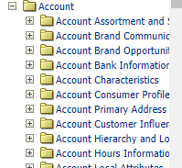

A new subfolder needs to be created inside Account entity in all SA where Account is located, called Account Update History and all fields in new approval history view need to be included:

* + Trading As
  + T&T EO_ID
  + T&T F_ID
  + New Trading As
  + New Retail T&T EO_ID
  + New Retail T&T F_ID
  + Update Status
  + Postcode
  + Primary Position
  + Account Handler position
  + Date Requested
  + Date Approved/Rejected
  + Details of Requester
  + Details of Approver/Rejection

There will be many records in Account Update History per Account.

## Data Dictionary

## Changes in Data Interfaces

## Inbound

|  |  |  |  |  |  |
| --- | --- | --- | --- | --- | --- |
| Specify Inbound OLTP/OLAP Entity - Interface Code E.g. *OLTP Asset Component - AE* | | | | | |
| **#** | **Entity** | **Field Name** | **Contents** | **Data type/format** | **Transformation** |
| 1 |  |  |  |  |  |
| # |  |  |  |  |  |

## Outbound

|  |  |  |  |  |  |  |
| --- | --- | --- | --- | --- | --- | --- |
| *Specify Outbound OLTP/OLAP Entity - Interface Code* E.g. OLTP Account Outbound – AO | | | | | | |
| # | **Entity** | **Field Name** | **Contents** | **Data type/format** | | **Transformation** |
| 1 |  |  |  |  |  | |
| # |  |  |  |  |  | |

## Initial Loads

* No impact

## Performance test / Indexes creation

* No impact

## Changes in Batch Processes / Aggregations / DRP

* No impact

## Use Case

|  |  |  |
| --- | --- | --- |
| Role  *Trade Marketer, ASM, Local Admin…* | Application  *Sales, Analytics, ETL, Batch, Interface* | Step  *Description of the step and its expected output* |
| Trade Marketeer - UK | Siebel Sales | Login to Siebel Sales  TM needs to navigate to an Account, create a visit and go to Visit – Rep Amendments view. Inform the three new fields New Trading As, New Retail T&T EO_ID and New Retail T&T F_ID with correct information. Validate that when informing these fields Date Requested, Details of Requestor and Update Status fields are correctly informed. Validate that if TM deletes all three fields Date Requested, Details of Requestor and Update Status are nullified.  If TM tries to inform T&T fields with an incorrect format a validation would appear. If TM tries to insert a duplicated value already existing in another account in T&T F_ID field an error message would appear. |
| Local Administrator UK | Siebel Sales | Login to Siebel Sales  Navigate to Accounts Administration – Pending Approvals view. Check that all Accounts which have some information on fields New Trading As, New Retail T&T EO_ID and New Retail T&T F_ID appear on this view. This should be all Accounts with Update Status=Pending.  Validate that when pressing Approval button, the information present on the New Trading As, New Retail T&T EO_ID and New Retail T&T F_ID is copied into the original Account fields. Validate that you could approve several records at once. Validate that Update Status has been modified to Approved, and Date Approved/Rejected and Details of Approval/Rejection fields have been informed.  Validate that if you press Reject button, the information in the New Trading As, New Retail T&T EO_ID and New Retail T&T F_ID fields is emptied without copying it into the original fields. Validate that Update Status has been modified to Rejected, and Date Approved/Rejected and Details of Approval/Rejection fields have been informed. |
| Local Administrator UK | Siebel Sales | Login to Siebel Sales  Navigate to Accounts Administration – History of approvals view.  Validate that you can find the history of all approvals/rejections on this view, and that you can correctly see the Date Requested, Details of Request, Date Approved/Rejected, Details of Approval/Rejection fields informed and all the original and new field values for the update. |
| Local Administrator UK | OBIEE | Validate that you can find on Account entity new fields: New Trading As, New Retail T&T EO_ID, New Retail T&T F_ID, Update status, Date Requested, Date Approved/Rejected, Details of Requester and Details of Approver/Rejection and that with these fields you would be able to generate a report where you can see all Accounts with pending approvals in TME.  Validate that you can find all fields in the history view available on OBIEE in a new subfolder inside Account entity called Account Update History. Check that all requested fields are visible including the old and new values for the updated fields, and the details of the approval/rejection. |